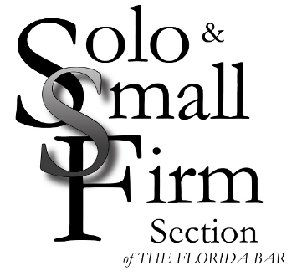
The Florida Bar
Solo & Small Firm Section
Member Spotlight Questionnaire
Please return completed form and photos to lisa@prflorida.com.

Name, firm and city:

What was your first job?

When did you know you wanted to practice law?

Do you have a unique experience that has influenced your professional life?

If you could have dinner with a celebrity or public figure, who would it be and why?

One thing most people do not know about you is:

Do you have a favorite quotation?

Who or what inspires you?

Do you have a favorite activity, sport, hobby or event?

What is one place that you would love to visit?

Family Information (siblings, spouse/partner, children, grandchildren, pets):

